**Name: Yogalakshmi Batch Name:** FSD60WE2-T

1. **Write a blog on Difference between HTTP1.1 vs HTTP2**

HTTP, the Hypertext Transfer Protocol, connects web browsers and servers for transferring data in various forms such as text, images, and videos. It has multiple versions including HTTP 0.9, HTTP 1.0, HTTP 1.1, HTTP 2.0, and the upcoming HTTP 3.

Now, let's delve into HTTP 1.1 and HTTP 2.0:

***HTTP 1.1:***

Released in 1997, it addressed some issues of HTTP 1.0, focusing on performance enhancement, connection pipelining, and transfer encoding.

***HTTP 2.0:***

An upgraded version of HTTP 1.1, released in 2015 by the Internet Engineering Task Force (IETF). It employs a binary framing layout for HTTP requests, allowing clients to send messages to the web using binary commands.

***Differences between HTTP 1.1 and HTTP 2.0:***

***Multiplexing:***

HTTP 1.0 handles one request at a time, while HTTP 1.1 allows multiple requests but with restrictions. HTTP 2.0, on the other hand, can handle multiple requests concurrently, enabling faster browser loading using a single connection.

***Server Push:***

HTTP 2.0 introduces server push, enabling servers to push content to the client before it's requested, whereas HTTP 1.1 lacks this feature and responds only after receiving requests.

***Header Compression:***

Both HTTP 1.1 and HTTP 2.0 offer facilities to compress files. However, HTTP 2.0 employs a more advanced compression method called HPACK, which eliminates redundant information in HTTP header packets, reducing the size of each packet.

***Stream Prioritization:***

HTTP 1.1 follows a head-of-line blocking approach, prioritizing the correct order of asset loading. In contrast, HTTP 2.0 allows browsers or clients to request assets in any order, and modern browsers automatically prioritize data streams.

In conclusion, HTTP 2.0 offers significant speed advantages over HTTP 1.1, with a 14% increase in speed. It also supports SSL for enhanced security purposes.

1. **Write a blog about objects and its internal representation in Javascript**

An object is a bunch of properties and properties are always defined with key value pairs i.e., (key:value = Name:Yogalakshmi). The key should always be a string. If the property’s value is represented by function, then it is called a method. The objects are represented in the curlibracket.

Javascript Objects are compared to real world objects. It has properties, methods, types and standalone entities in it. Eg: how the pen has its own properties like shape, color and ink color, etc.

***How to create a new object in javascript?***

Creating a new object is called as object literal or object initialiser which starts with either var, let and const along with object name. The things inside the object are called the properties with key value pairs.

***syntax:***

**Var object name = {**

**Key 1: value1,**

**Key 2: “value2”,**

**Key3: value 3**

**}**

**console.log(object name)**

The object name can be defined with either var or let or const. The variable is used to store the data under the object name. Key 1,2,3 are the identifiers and value 1 can be represented as number, value 2 can be represented as string i.e. given in double cot and value 3 may be Boolean either given true or false.

**Eg:**

**Var data = {**

**name: "Yogalakshmi",**

**age: 31,**

**qualification:"M.E",**

**}**

**console.log(data)**

Data is an object with is mentioned with curl bracket. Inside the curl bracket, the key values are given. To get the output, the console.log (object name) is used.

***Another method to create object:***

**Eg:**

**var data =new Object();**

**data.name ="yogalakshmi"**

**data.age = 31**

**data.qualification ="M.E"**

**console.log(data)**

**Output: { name: 'yogalakshmi', age: 31, qualification: 'M.E' }**

Items are stored in variables and properties are also stored in variables. If you want to add the key values in the object, we can use the dot function. **Eg: objectname.key= value**

***Update the data in the object:***

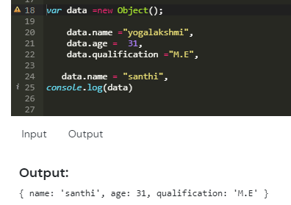

To update the any of the key and values, we can use **objectname.key = “value” or objectname[“key”]=”value”**

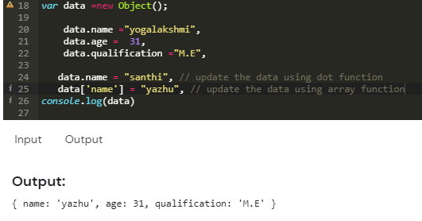

***How to create the object and array inside the object:***

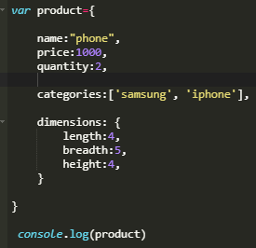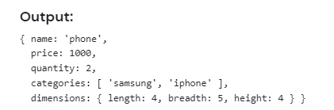

Dimension is the object created inside the object which can print separately in the output. Arrays can also be created inside the objects by categories in the example.

***How to get the particular properties in the output?***

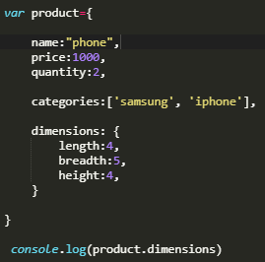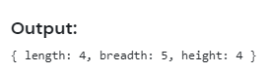

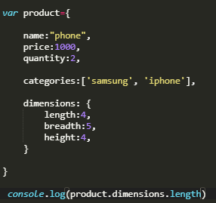

Give the objectname.keys inside the console.log to get the separate properties output.

***How to write the function inside the object?***

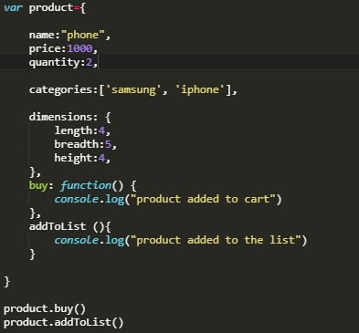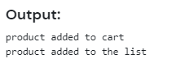

The function can be performed in two ways either with buy:function(){......} or addToList(){..........} . the console.log is no need to give because inside the function it is given already, so outside the object, just print the product.buy() for output.